**PF LAB 3 ASSIGNMENT**

Q1: Explain the output of this c program. Why the wrong value is being displayed in the output?

Q2: Write a c program that takes two integer values as input from the user. Then swap the values taken from the user and display the output of the variables.

Q3: A customer asks the IT firm to develop a program in C language, which can take tax rate and salary from the user on runtime and then calculate the tax, the user has to pay and the salary he/she will have after paying the test. This information is then provided to the user.

Q4: A car travelled back and forth from point A to B. With a distance being (single trip) 1207 KM. During the forward trip fuel price was 118/liter while returning it was 123/liter. Calculate the total fuel cost(both ways) and the fuel consumed (total trip). Use the cars fuel average as input from the user (input must be positive make some restrictions on only accepting positive input)

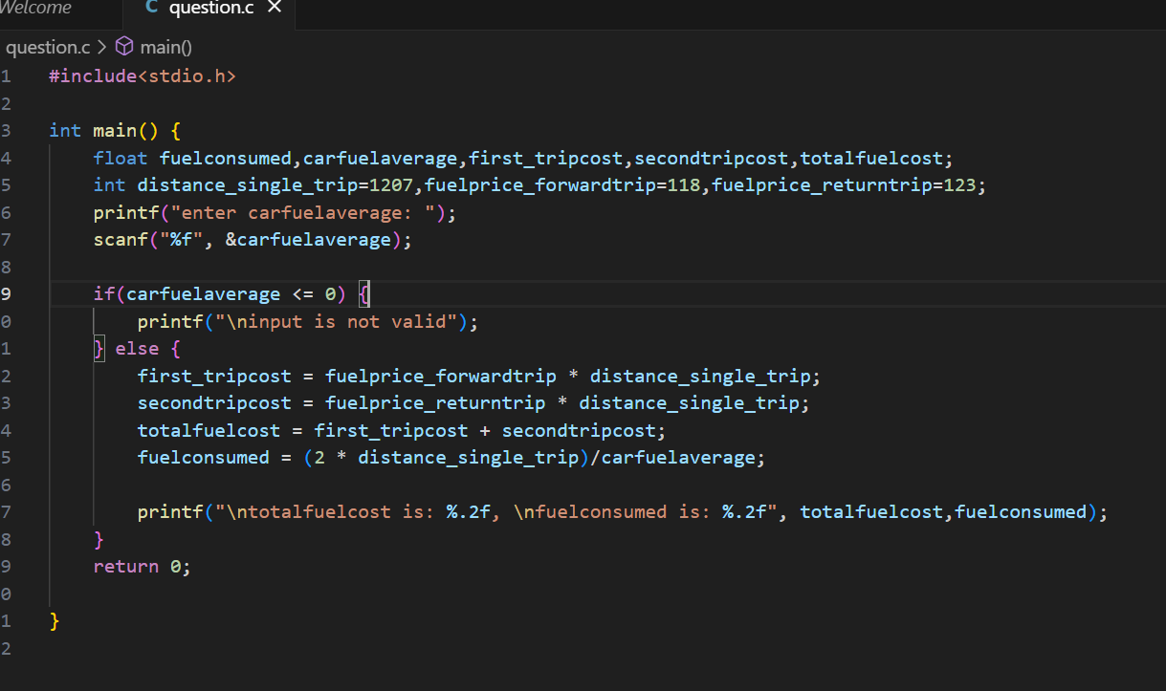

Q5: Construct a c program the input value of the principle must be between 100 Rs to 1000000 Rs. The rate of interest must be between 5% to 10% and time period must be between 1 to 10 years.

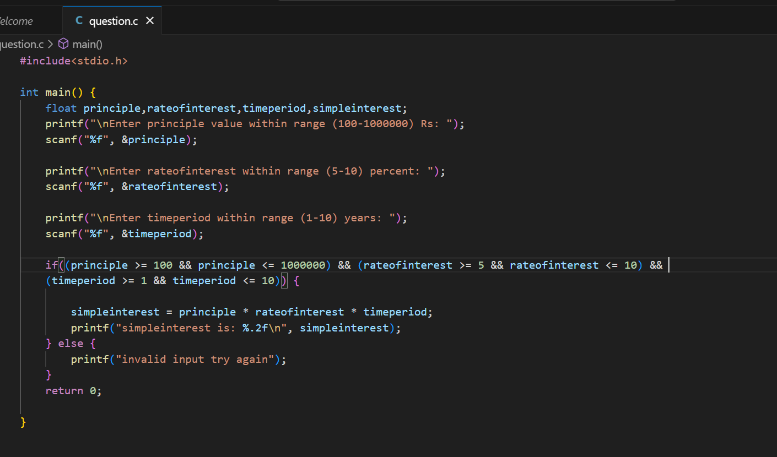

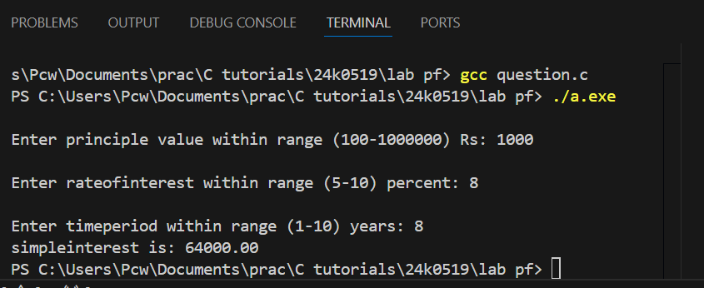

Q6: Construct a C program where you can calculate the slope of two point (5,4),(3,2). Use format specifiers to cap the result to 3 decimal places.

